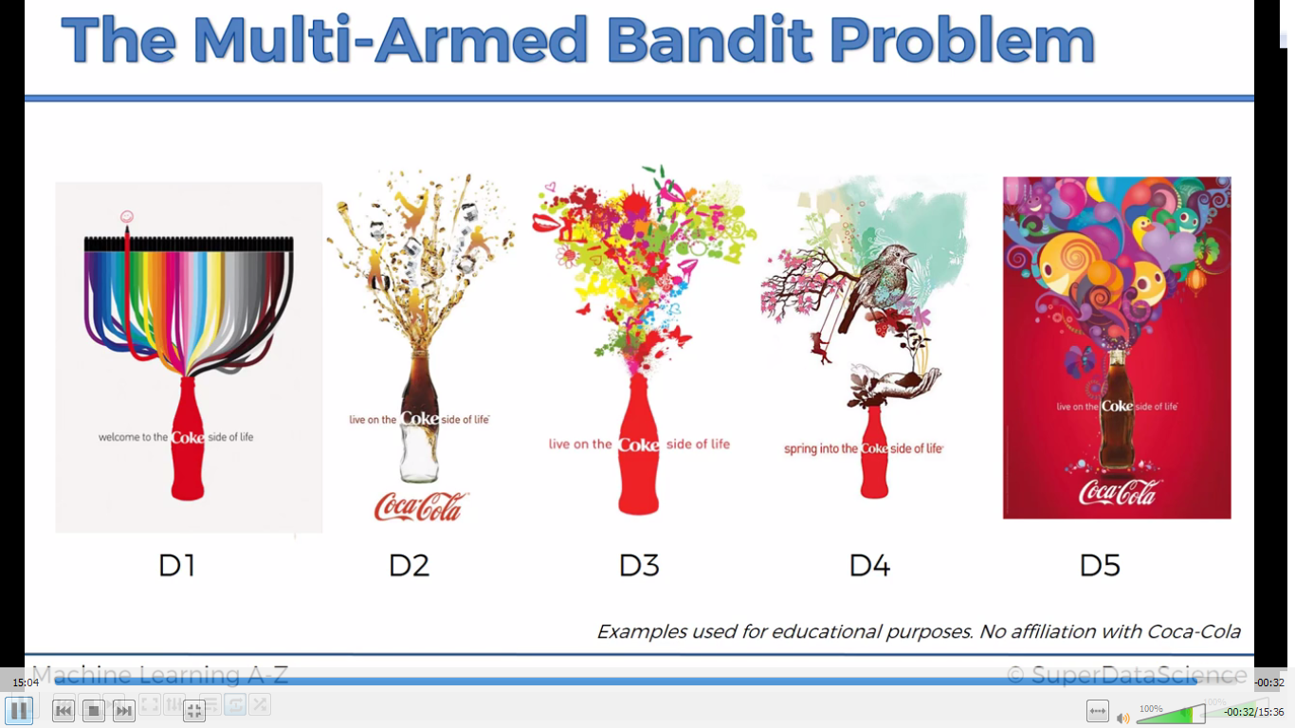

WHAT IT IS?

Here we need to find out which ad is getting most clicked. One way is simple A/B testing where we take huge amount of dataset and check on basis of confidence which is getting clicked .the con is that we cannot waste time and use large dataset, we should be able to learn steeply through the process of collecting data.

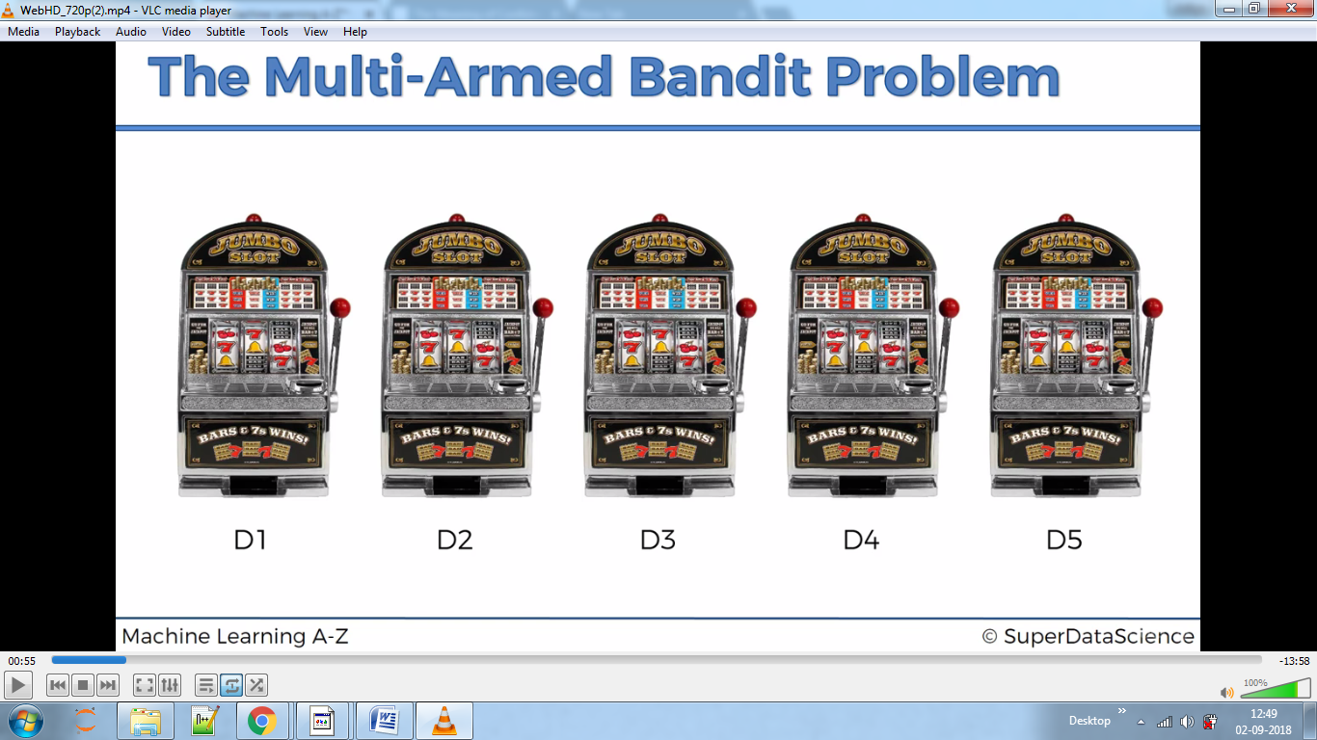

Here we know each machine has different distribution.

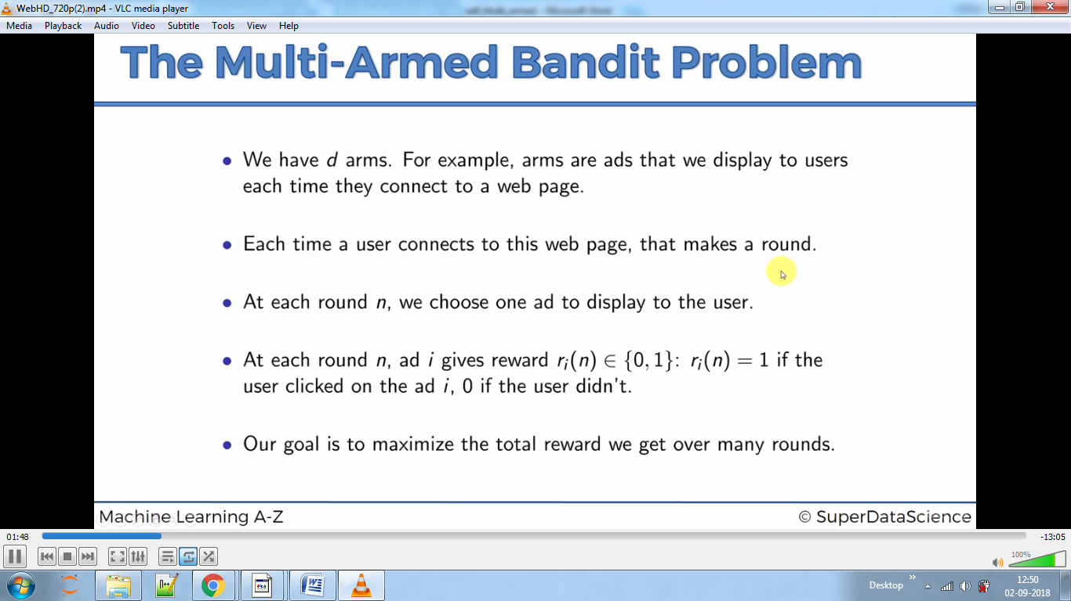

Let’s say we know end results:-

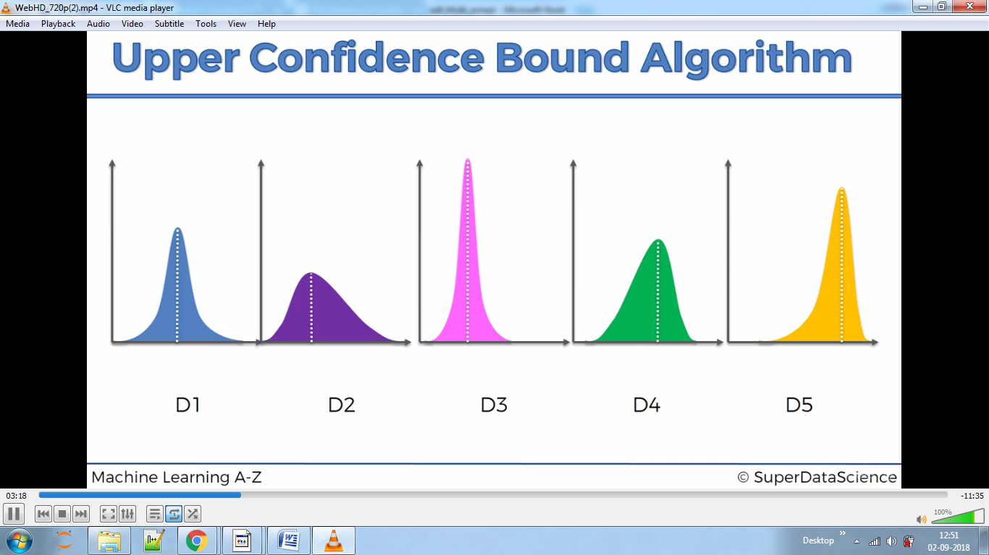

From above plotting dotted white line x axis value on y axis below.

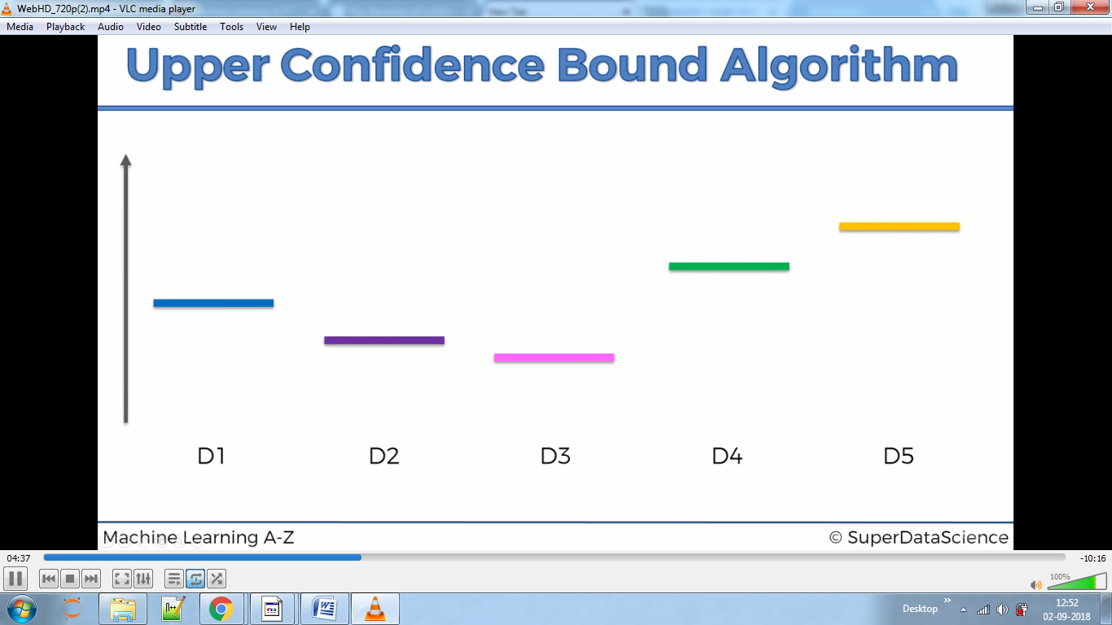

Below we put a red dotted line randomly and then the algorithm generates confidence width which should include our original result-the blue, violet etc lines.

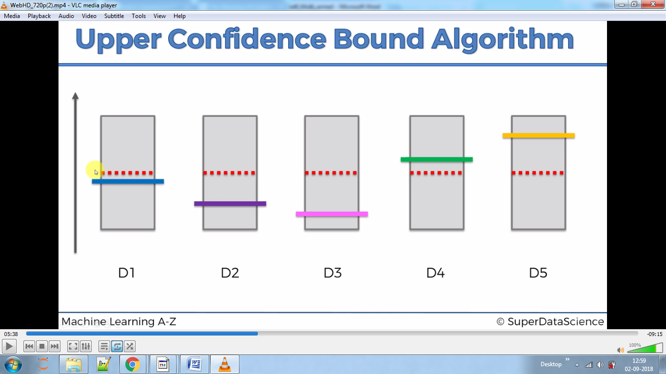

Then we pick the one which has highest confidence bound ,here all are same say we take 3rd one

Where the algorithm will move red line towards pink(may move above or below depending on algorithm) and as the pink line remains in the confidence width hence we decrease the confidence width and then again choose one with higher confidence bound and repeat same process.

We will reach now :-

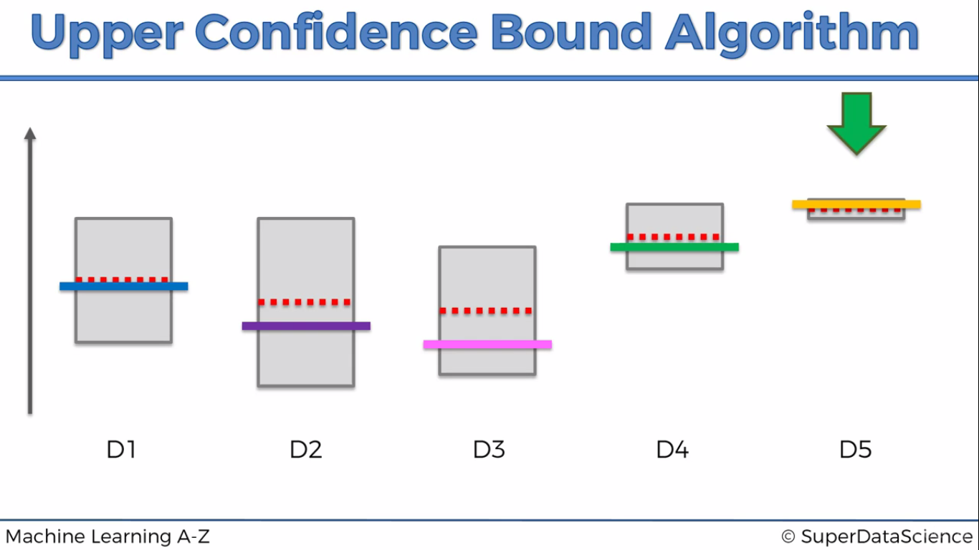

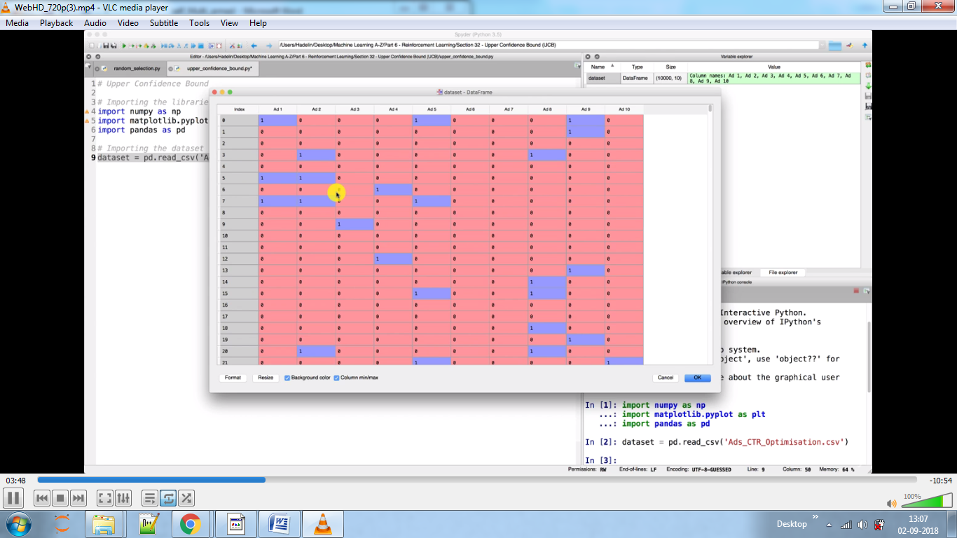

Here we have 10 versions of ads and company needs to find out for us which version appeals more to the customers as they cannot spend their money in each version.

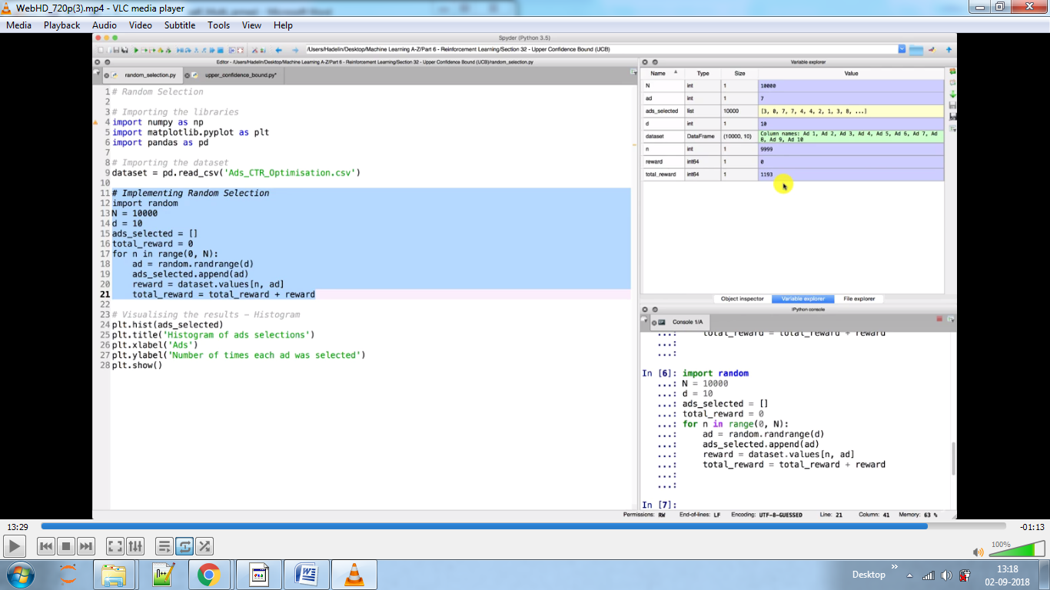We used a random selection function which assigns on its own user will click on which version.



Say in first case it says 4 i.e. the 5 version user will click.(see table)

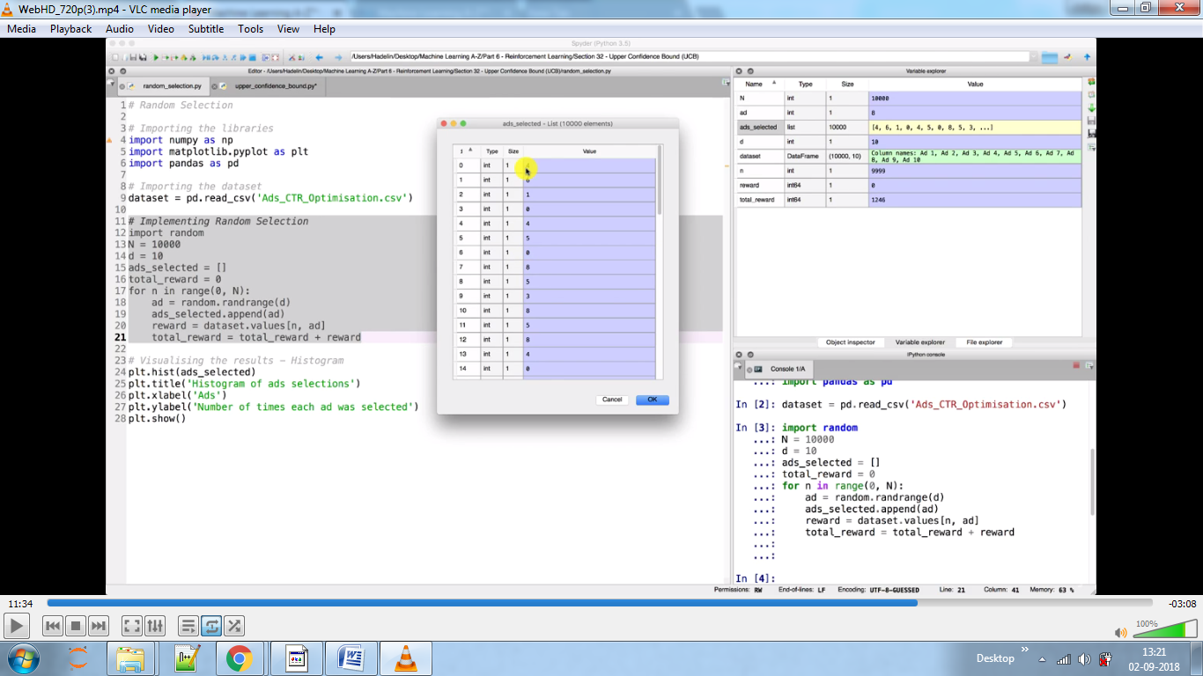

The total reward is sum of values in column which has 4 as its first value.

Upper bound Algorithm

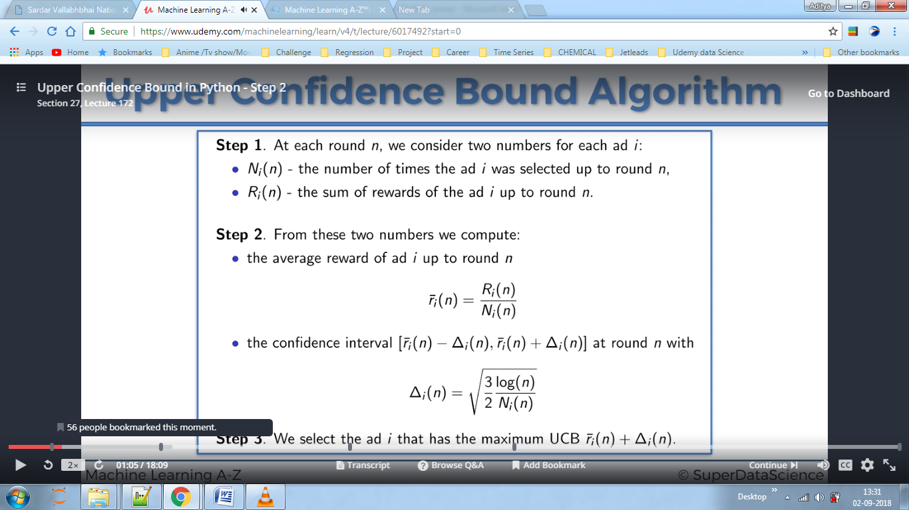

**See code to understand. It gave us results twice as better than random confidence method.**